

# Department of Computer Science and Engineering

**Global Campus, Jakkasandra Post, Kanakapura Taluk, Ramanagara District, Pin Code: 562 112**

**2022-2023**

**A Project Phase II Report on**

### “Unmanned Automated Vehicle”

**Submitted in partial fulfilment for the award of the degree of**

**BACHELOR OF TECHNOLOGY IN**

**COMPUTER SCIENCE AND ENGINEERING**

**Submitted by**

**Adit Vikram Mishra**

**19BTRCS086**

**Mannan Dassani**

**19BTRCS041**

**Vaishakh R N**

**19BTRRA022**

**Under the guidance of**

**Dr. Rajat Bhardawaj**

Professor

Department of Computer Science & Engineering

Faculty of Engineering & Technology

**JAIN Deemed to be University**



# Department of Computer Science and Engineering

**Global Campus, Jakkasandra Post, Kanakapura Taluk, Ramanagara District, Pin Code: 562 112**

# CERTIFICATE

This is to certify that the project work titled **“Unmanned Automated Vehicle”** is carried out by **Adit Vikram Mishra (19BTRCS086), Mannan Dassani (19BTRCS041), Vaishak R N (19BTRRA022),** a bonafide students of Bachelor of Technology at the Faculty of Engineering & Technology, Jain Deemed-to-be University, Bangalore in partial fulfillment for the award of degree in Bachelor of Technology in Computer Science & Engineering, during the year **2022-2023**.

|  |  |  |  |
| --- | --- | --- | --- |
| **Dr. Rajat Bhardwaj** | **Dr.R.Chandramma** | ***Dr. Mahesh T R*** | **Dr. S A Hariprasad** |
| Professor,  Dept. of CSE,  Faculty of Engineering & Technology,  Jain Deemed to be University  Date: | Assistant Professor  Dept. of CSE,  Faculty of Engineering & Technology,  Jain Deemed to be University  Date: | Program Head, Dept. of CSE,  Faculty of Engineering & Technology,  Jain Deemed to be University  Date: | Director,  Faculty of Engineering & Technology,  Jain Deemed to be University  Date: |

Name of the Examiner Signature of Examiner

1.

2.

# DECLARATION

We, **Adit Vikram Mishra (19BTRCS086), Mannan Dassani (19BTRCS041), Vaishak R N (19BTRRA022)** are students of seventh semester B.Tech in **Computer Science & Engineering**, at Faculty of Engineering & Technology, **Jain Deemed to-be University**, hereby declare that the project titled **“Unmanned Automated Vehicle”** has been carried out by us and submitted in partial fulfilment for the award of degree in **Bachelor of Technology in Computer Science & Engineering** during the academic year **2022-2023**. Further, the matter presented in the project has not been submitted previously by anybody for the award of any degree or any diploma to any other University, to the best of our knowledge and faith.

Signature

|  |  |
| --- | --- |
| Name1: Adit Vikram Mishra  USN: 19BTRCS086 |  |
| Name 2: Mannan Dassani  USN:19BTRCS041 |  |
| Name 3: Vaishak R N  USN: 19BTRRA022 |  |

## ACKNOWLEDGEMENT

*It is a great pleasure for us to acknowledge the assistance and support of a large number of individuals who have been responsible for the successful completion of this project work.*

*First, we take this opportunity to express our sincere gratitude to Faculty of Engineering & Technology, Jain Deemed to be University for providing us with a great opportunity to pursue our Bachelor’s Degree in this institution.*

*In particular we would like to thank* ***Dr. S A Hariprasad****, Director, Faculty of Engineering & Technology, Jain Deemed to be University for their constant encouragement.*

*we would like to thank* ***Dr. Geetha****, Dean Academic, Faculty of Engineering & Technology, Jain Deemed to be University for their constant encouragement and support.*

*It is a matter of immense pleasure to express our sincere thanks to* ***Dr. Rajesh A. , Head of the Department****,* ***Computer Science & Engineering****, Jain Deemed to be University****,*** *for providing right academic guidance that made our task possible.*

*we would like to thank* ***Dr. Mahesh T R****, Program Head, Faculty of Engineering & Technology, Jain Deemed to be University for their constant encouragement and expert advice.*

*We would like to thank our guide* ***Dr. Rajat Bhardawaj*** *Assistant Professor,* ***Dept. of Computer Science & Engineering****, Jain Deemed to be University, for sparing his/her valuable time to extend help in every step of our project work, which paved the way for smooth progress and fruitful culmination of the project.*

*We would like to thank our Project Coordinator* ***Dr.* R.Chandramma** *and* ***Dr. Rajat Bhardawaj*** *and all the staff members of Computer Science & Engineering for their support.*

*We are also grateful to our family and friends who provided us with every requirement throughout the course.*

*We would like to thank one and all who directly or indirectly helped us in completing the Project phase1 work successfully.*

*Signature of Students*

# ABSTRACT

In recent years, the role of freight transportation and parcel delivery in urban areas has increased, supporting the economic and social development of cities. At the same time, the industry is affected by various issues, inefficiencies, and externalities, particularly in the last-mile segment. As such, there is an emerging awareness of a need to improve urban mobility and transportation, making them more sustainable and competitive by mixing traditional and emerging technologies.

Last mile delivery of food/groceries has lately been taken over by Swiggy, Dunzo, Zomato, etc.

But as good as their revenue is ,they are struggling to find ways to increase profitability

Factors leading to inefficiencies

* Inefficient time management, that is: delayed pickups from store
* Delivery partner fees , the driver needs incentives to work in harsh conditions such as rain or cold nights
* Traffic - urban traffic can drastically reduce no of deliveries possible ,in which the wait time is a direct waste of delivery partners time
* Cap of 1-2 orders per delivery cycle
* Fatigue and breaks , this leads to requiring more delivery partners and increases the total incentives that’s needed to be paid by the logistics partners

viii

## TABLE OF CONTENTS

|  |  |
| --- | --- |
|  | Page No |
| List of Figures | vii |
| Nomenclature used | vii |
| Abstract | viii |
| **Chapter 1** | **01** |
| **1.** INTRODUCTION | 01 |
| **Chapter 2** | **02** |
| **2.** Literature Survey | 02 |
| **Chapter 3** | **04** |
| **3.** Objective and Methodology | 04 |
| 3.1 Objective | 04 |
| 3.2 Methodology | 04 |
| **Chapter 4** | **05** |
| **4.** System Design | 05 |
| 4.1 ROS Information | 05 |
| 4.2 Algorithms used  4.3 Liquid Cooling system | 10 |
| **Chapter 5** | **11** |
| **5.** Hardware and Software requirement | 11 |
| 5.1 Hardware requirement | 11 |
| 5.2 Software requirement | 11 |
| Conclusion | 12 |
| References | 13 |

**LIST OF FIGURES**

|  |  |  |
| --- | --- | --- |
| Fig. No. | Description of the figure | Page No. |
| 1.1 | Baja rally car | 7 |
| 4.1 | Robot Operating System | 12 |
| 4.2 | YOLOv5 | 15 |
| 4.3 | Obstacle avoidance system | 16 |
| 4.4 | Liquid Cooling System | 16 |
| 5.1 | D300 LD19 DTOF Laser Ranging Sensor | 17 |
| 5.2 | mmWave RADAR (9m) | 17 |
| 5.3 | Brushless Controller for 1000W 48V BLDC Motor | 17 |
| 5.4 | Refurbished – 1000W 48V Brushless DC Motor | 18 |
| 5.5 | 1800W 40A DC to DC Adjustable Constant Voltage and Current Power Supply Module | 18 |
| 5.6 | Arduino Uno | 18 |
| 5.7 | Raspberry Pi 4 | 19 |
| 5.8 | Universal Battery Elimination Circuit | 19 |
| 5.9 | TFMini-S Micro LiDAR Distance Sensor | 19 |
| 5.10 | Skeleton | 20 |
| 5.11 | Drive Train | 20 |
| 5.12 | Complete components | 21 |
| 5.13 | finished product | 21 |

## NOMENCLATURE USED

|  |  |
| --- | --- |
| YOLO | You Only Look Once |
| CNN | Convolution Neural Networks |
| ROS | Robot Operating System |

vii

# Chapter 1

# INTRODUCTION

Our Unmanned Automated Vehicle is a concept delivery vehicle built to ease hub to point and subsequently point to point deliveries within urban zones.

Built on a modular platform (shown below) perceptron is a modular EV platform with a rugged off-road chassis inspired by the Baja rally cars.

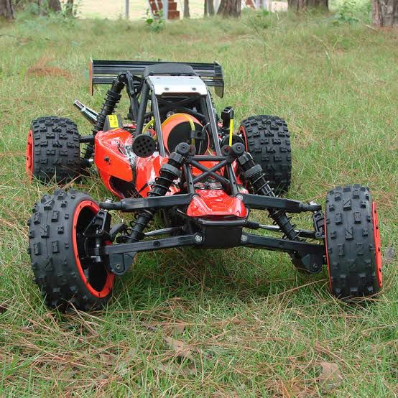

fig. 1.1 Baja rally car

This allows perceptron to take on multiple roles in many industrial and commercial applications which tend to utilize our suspension system to almost it potential such as the roads of our own city Bengaluru.

# Chapter 2

# LITERATURE SURVEY

**Atia, M.M., Hilal [1]** This paper presented a low-cost lane-determination system that fuses MEMS IMU with standard SPS GPS technology and commercially available road network maps that provide unbiased road-center positioning. The system estimates the vehicle’s 3D state using an EKF and then it applies an efficient two-phase multi-stage map-matching procedure using HMM and LS. The advantage of the proposed two-stage multiresolution map matching method is the reduced complexity of HMM decoding step as compared to the case if HMM is applied directly over large number of lanes. This also eliminates the need for explicit storage of lane geo-spatial information.

**Baruch, J.**, **[2]** author proposed “*Steer driverless cars towards full automation*” in which he compared ways of steering driverless cars. Car manufacturers may find that the information they glean from tracking the lifestyle of their customers is worth much more than their vehicles. He talks about using no steering wheel and no opportunity for people to take control or with steering wheels. The efforts of the luxury car brands are reminiscent of when gas companies tried to improve lighting by adjusting lantern mantles when electric lighting appeared.

**Gim Hee Lee, F.F. and Pollefeys, M [3]** demonstrated visual ego-motion estimation for a car equipped with a multi-camera system with minimal field-of-views. The camera system was modeled as a generalized camera and we showed that the generalized essential matrix simplifies significantly when constraining the motion to the Ackerman motion model. They evaluated our method on a large real-world dataset and compared it to GPS/INS ground truth. The results of the comparison clearly showed that our assumptions on the vehicle motion hold for real-world data.

**Lee, J.-G., Kim, K.J., Lee, S. and Shin [4]** In this paper the author talks about what automation technology is increasingly replacing human to perform complex tasks such as driving, eliminating human intervention from driving may imply significant safety and trust related concerns. Their study applies layers of anthropomorphic cues to an artificial driving agent to promote positive perceptions of an unmanned driving system. In a between-subjects factorial experiment (N = 89), participants interacted with an artificial driving agent with different levels of anthropomorphism induced by the variations in appearance (human-like vs. gadget-like) and autonomy (high vs. low) of the agent.

**Mohamed, R., Aly, H. and Youssef, M. [5]** This author presented SnapNet, a real-time map matcher for noisy cellular-based trajectory traces. SnapNet is unique in targeting mainstream cell phones which can only provide its associated cell-info for localization systems; opening up new possibilities for location-based services from both network and client side. They provided the SnapNet’s system architecture and the different filtering and preprocessing modules that help it reduce the noise in the input data and handle the data sparsity.

**N. Kassem, A. E. Kosba, and M. Youssef [6]** In this research paper, the authors presented the design and analysis of the ReVISE system that enables vehicle motion detection and speed estimation using RF signal strength information without using special hardware. ReVISE uses a multi-class SVM classifier to provide the detection capability. Two methods were proposed for speed estimation: the first method is based on a statistical technique that depends on the significant change in the signal strength of the border streams when a vehicle enters or exits the area of interest. The other method is based on a curve-fitting technique that captures the relation between the signal strength variance and vehicle speed.

# Chapter 3

# OBJECTIVE AND METHODOLOGY

* 1. **Objective**

• The main objective is to build a system that can drive from one point to another.

• Detects the obstacles using external sensors like LIDAR, depth camera, etc.

• Has integrated electronic systems to implement algorithms that need the above said data to find its path.

• Result into an affordable automated transport solution for all kinds of users.

## Methodology

The system works using the inputs from the various sensors inside the vehicle to processes and calculate what decision to take in the real time environment.

The LIDARs provide spatial data that tells the size and distance of any obstacle that might hinder the journey of the vehicle or cause any accidents. The cameras provide data to the machine learning algorithm to take immediate actions for the vehicle.

The Tinker Edge R is the brains of the whole system which provides the required integration required for all the technologies to work together. For connectivity the Tinker Edge R mini-PC is comes with a wide range of hardware including a full-size HDMI port, USB Type-A, USB Type-C, Gigabit LAN and Wi-Fi and Bluetooth, as well as a mini-PCI Express Mini slot supporting a 4G/LTE extension card if required. Tinker Edge R also comes equipped with an onboard 16 GB eMMC and SD 3.0 interface. Tinker Edge R features 4 GB of dual-channel LPDDR4 system memory, the 4th generation of low-power DDR DRAM technology, offering faster speeds and even lower power consumption for improved system performance and efficiency. It also boasts 2 GB of standalone memory for the NPU, delivering faster speeds, improved stability and high efficiency for ML inference. ASUS provides a robust API and SDK that enables users to deploy ML models to Tinker Edge R easily for applications such as image classification and object detection. It also supports model conversion from Caffe, TensorFlow, TensorFlow Lite and more.

It also has feature to track objects as well. It uses YOLO algorithm for maximum performance with least processing. YOLO is an abbreviation for the term ‘You Only Look Once’. This is an algorithm that detects and recognizes various objects in a picture (in real-time). Object detection in YOLO is done as a regression problem and provides the class probabilities of the detected images. The project also covers the mechanical aspect for its completion which is discussed in chapter 5.

1. **Steering**

The CNN network has access to a wealth of information that can be used to

predict the steering angle, including the angle of lane lines, the curvature of the

road, the location of signboards, the turning angle of other vehicles and

pedestrians, and the curvature of mid-road dividers. Computer vision techniques

can also be employed to find the angle of lane lines on the road, which can help

determine the steering angle.

To predict the steering angle for each frame, a CNN model can be fed a set of

steering angles and corresponding frame images, with the goal of minimizing

MSE training loss. After multiple iterations and epochs of training, the model can

be used to predict the steering angle, even in uneven environments such as those

found in India. The end-to-end CNN architecture for self-driving cars developed

by NVidia is utilized for this purpose.

1. **Acceleration and Breaking**

The acceleration and brake of a vehicle are dependent on the sequence of frames

captured by the camera. Optical flow is a method for determining the apparent

motion of objects and edges in a scene caused by the relative motion between an observer and a scene. For example, if a corner has moved from position C to C' in one frame to the next, the optical flow can be calculated by summing up the distance shift of all the corner points across the previous frames.

*cv2.goodFeaturesToTrack(previous_frame, mask=None,*

*\*\*feature_params)*

The cv2 library in python provides tools that are needed to find the corners in

subsequent frames.

To make the vehicle work, both the steering and acceleration/braking

models need to be run together on the Tinker Edge T. The Tinker Edge T

uses the Robot Operating System (ROS) to receive input from the

predictions made by the models and send them to the micro-controllers

that control the stepper and servo motors. These micro-controllers, which

are typically Raspberry Pi 4, also use ROS libraries in their code to enable

communication with the main processor.

# Chapter 4

# SYSTEM DESIGN

**4.1 ROS INFORMATION**

ROS (Robot Operating System) provides libraries and tools to help software developers create robot applications. It provides hardware abstraction, device drivers, libraries, visualizers, message-passing, package management, and more. ROS is licensed under an open source, BSD license.

Robot Operating System (ROS) is a set of open-source algorithms, hardware driver software and tools developed to develop robot control software. Even though it has operating system in its name it is not an operating system. It is

• Communication System (Publish Subscribe and Remote Method Invocation),

• Framework & Tools (Build system & dependency management, Visualization, Record and Replay)

• Ecosystem (Language bindings, Drivers, libraries and simulation (Gazebo)).

OS includes mature open-source libraries to be used for navigation, control, motion planning, vision and simulation purposes. The 3D visualization tool called RVIS is an

important tool used with ROS.

Similarly, the simulation tool called Gazebo is seen as a useful tool for robot developers. Apart from this, Open CV library is a library used for detection purposes in ROS 2. In addition, we see that the QT graphic library is also used for the user interface in ROS 2 projects and is an add-on available for this purpose.

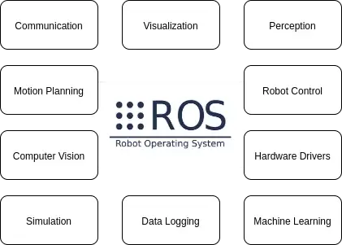

*Fig 4.1 Robot Operating System*

**ROS 2 Architecture**

ROS 2 has provided its own abstraction layer (rmw) on top of DDS instead of directly using the DDS middleware. Thus, the details of the DDS middleware interface are abstracted from the user. In the current ROS 2 versions, Fast-DDS comes as the standard DDS version. Apart from that, rmw support is available in different DDS products. The user can select and use the DDS library they want, and even thanks to the network level interoperability, it is possible to use more than one DDS library in the same project.

ROS 2 is a middleware based on an anonymous publish/subscribe mechanism that allows for message passing between different ROS processes.

At the heart of any ROS 2 system is the ROS graph. The ROS graph refers to the network of nodes in a ROS system and the connections between them by which they communicate.

**Graph Concepts**

* Nodes: A node is an entity that uses ROS to communicate with other nodes.
* Messages: ROS data type used when subscribing or publishing to a topic.
* Topics: Nodes can publish messages to a topic as well as subscribe to a topic to receive

messages.

* Discovery: The automatic process through which nodes determine how to talk to each other.

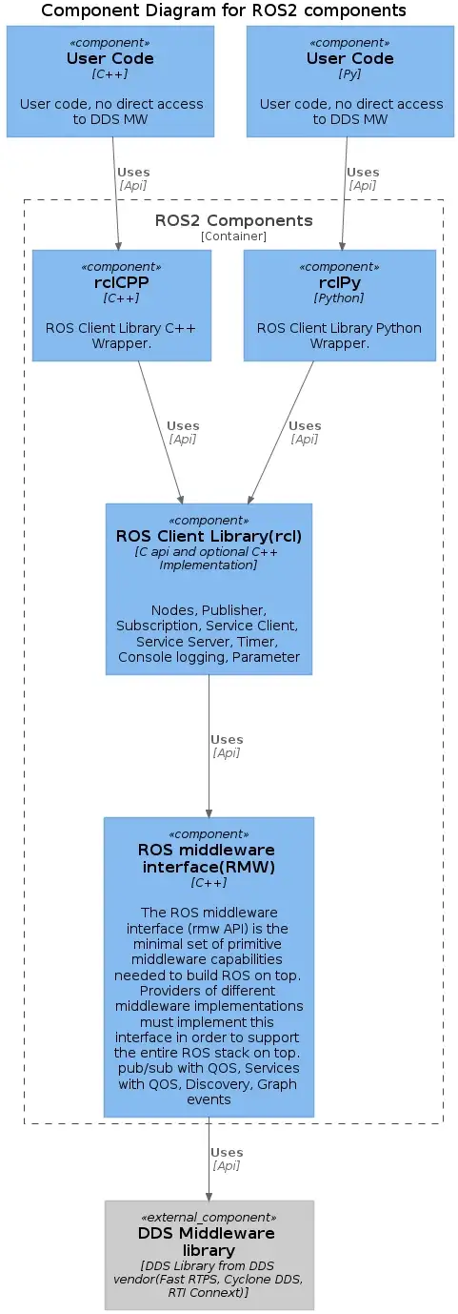

**Nodes (how parts communicate with each other)**

A node is a participant in the ROS graph. ROS nodes use a ROS client library to communicate with other nodes. Nodes can publish or subscribe to Topics. Nodes can also provide or use Services and Actions. There are configurable Parameters associated with a node. Connections between nodes are established through a distributed discovery process. Nodes may be located in the same process, in different processes, or on different machines. These concepts will be described in more detail in the sections that follow.

**Security**

ROS 2 includes the ability to secure communications among nodes within the ROS 2 computational graph. Similar to discovery, security happens through the underlying ROS 2 middleware (provided it has support for the corresponding security plugins). No additional software installation is needed to enable security; however, the middleware requires configuration files for each ROS graph participant. These files enable encryption and authentication, and define policies both for individual nodes and for the overall ROS graph. ROS 2 also adds a master “on/off” switch to control security behavior.

ROS utilities can create the authoritative trust anchor for a ROS application, or an external certificate authority can be used.

## 4.2 Algorithm

## Object Detection

In this approach we use the knowledge that was gained from solving another task, to solve the task at hand. As vehicles always navigate in different speeds, the object scale varies violently, which burdens the optimization of networks. Moreover, high-speed bring in the motion blur on the densely packed objects, which leads to great challenge of object distinction. First, a high-resolution training dataset is augmented with the adaptive clipping algorithm. Then, a new training set is generated to retain the detailed features that the object detection network needs to learn. During the network detection process, the image is

detected in chunks via the adaptive clipping algorithm, and the coordinates of the detection

results are merged by position mapping. Finally, the chunked detection results are collocated with the global detection results and outputted. The improved YOLO algorithm is used to conduct experiments comparing this algorithm with the original algorithm for the detection of test set vehicles.

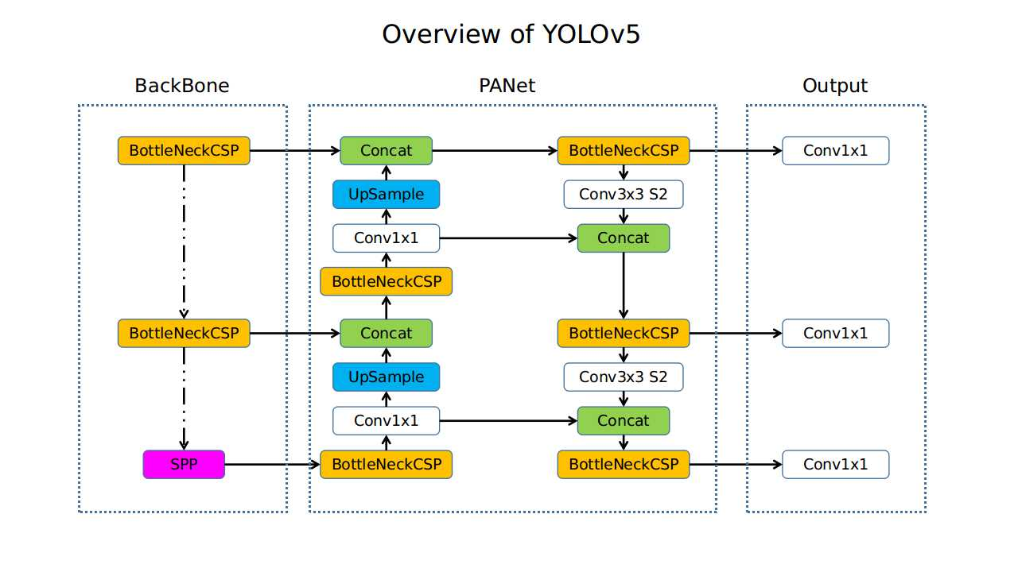

*fig 4.2 YOLOv5*

**Obstacle Avoidance**

Using 3D-LIDAR and front views and color image data as inputs. The top view LIDAR data is used to generate 3D object proposals. The 3D proposals are projected to three views for obtaining region-wise features. A region-based feature fusion scheme is used for the classification and orientation estimation. This approach enables interactions of intermediate layers from different views. We’ll use the YOLO model that we trained for Object Detection in sync with the LIDAR data to make very accurate decisions to the ever-changing situations that the vehicle might face while travelling. Using YOLOv5 and LIDAR-based depth map,

and combine the classification outputs at decision level using convolutional feature maps, category probabilities and SVMs.

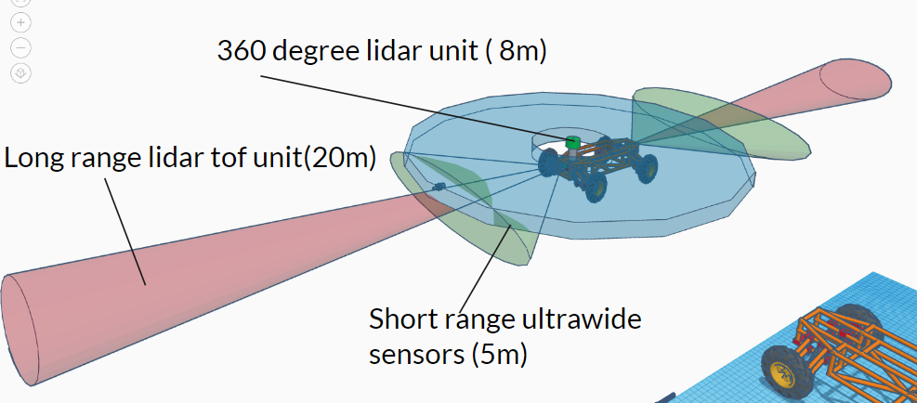

*fig 4.3 Obstacle avoidance system*

**4.3 Liquid Cooling System**

As with air coolers, there’s a wide selection of available options, but most fall into two categories: All-in-One (AIO) coolers, or custom cooling loops. We’ll mostly be focusing on All-in-One (AIO) coolers here, though the fundamental principles of how the liquid cools the CPU are the same in both. Similar to air cooling, the process starts with a baseplate that is connected to the IHS of the CPU with a layer of thermal paste. This allows for better heat transfer between the two surfaces. The metal surface of the baseplate is part of the waterblock, which is designed to be filled with coolant. The coolant absorbs heat from the baseplate as it moves through the waterblock. It then continues to move through the system and upward through one of two tubes to a radiator. The radiator exposes the liquid to air, which helps it cool, and fans attached to the radiator then move the heat away from the cooler. The coolant then re-enters the waterblock, and the cycle begins again.

We have built an advanced cooling solution for our bot as we are looking for endurance and 24/7 operational capabilities, we have considered this as a core part of the design aspect and have a system capable of dumping 1200 w of heat actively.

The system consists of two 240 mm radiators with a large reservoir and pump systems built with redundancy in mind its used to cool two heat plates one for the battery management system and one for the compute unit.

cpu/gpu

hot plate

Radiator #1

Reservoir and pumps

Battery management system Hot plate

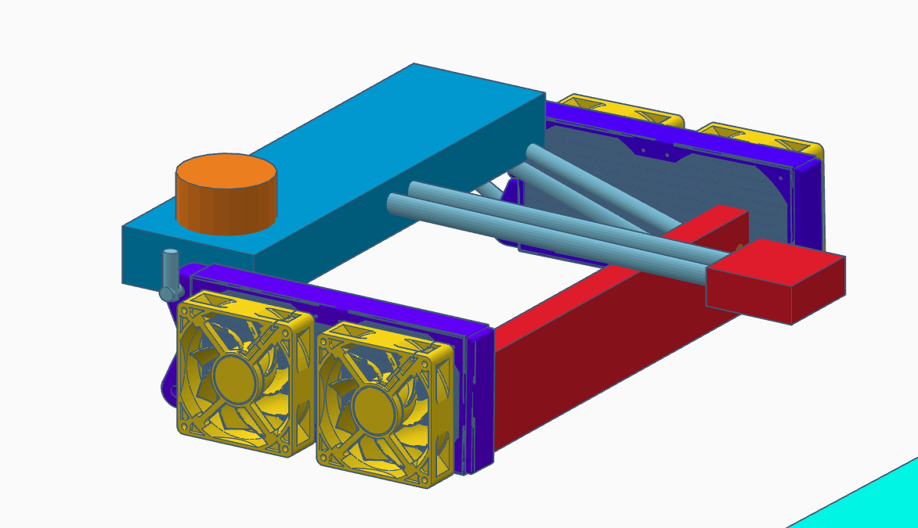

Radiator #2

*fig 4.4 Liquid Cooling System*

# Chapter 5

### HARDWARE AND SOFTWARE REQUIREMENTS

The following are basic hardware and software required to build and test the program.

* 1. **Hardware Requirements**

1. D300 LD19 DTOF Laser Ranging Sensor

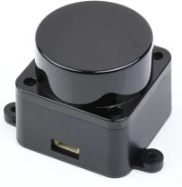

A laser ranging sensor, also known as a LIDAR (Light Detection and Ranging), is a device that uses laser light to measure the distance to a target object or surface.

The sensor emits a laser beam, which travels to the target and bounces back to the sensor. By measuring the time it takes for the laser light to travel to the target and return, the sensor can calculate the distance between itself and the target with high accuracy.

Laser ranging sensors are used in a variety of applications, including robotics, autonomous vehicles, 3D mapping, surveying, and more. They are particularly useful in situations where accurate distance measurement is required, such as in obstacle avoidance systems or in determining the shape and location of objects.

Laser ranging sensors can operate in a variety of wavelengths, from visible light to infrared and ultraviolet. The range and accuracy of the sensor depend on various factors, such as the power of the laser, the quality of the sensor's optics, and the atmospheric conditions in which the sensor operates.

1. MM 3Wave RADAR (9m)

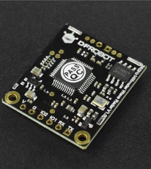

The MM 3Wave RADAR (9m) is a type of radar system that operates at three different frequencies simultaneously, which allows it to provide highly accurate and detailed information about the environment.

The radar system operates at frequencies of 94 GHz, 140 GHz, and 220 GHz, which allows it to provide information on a range of different types of targets, from large objects like buildings and vehicles to smaller objects like pedestrians and bicycles. The system has a range of up to 9 meters and can provide information on the location, velocity, and direction of movement of objects within its field of view.

The MM 3Wave RADAR (9m) is used in a variety of applications, including automotive safety systems, industrial automation, and surveillance systems. Its ability to detect and track small and fast-moving objects makes it particularly useful in applications where high-speed detection and response are critical.

The system operates using a combination of advanced signal processing techniques and sophisticated algorithms to analyze the radar signals and extract information about the environment. Its high-frequency operation allows it to provide very detailed information on the size, shape, and movement of objects, making it a valuable tool for a range of different applications.

1. Brushless Controller for 1000W 48V BLDC Motor

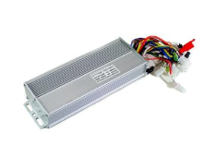

A brushless controller for a 1000W 48V BLDC (Brushless DC) motor is an electronic device that controls the speed and direction of the motor. It uses an electronic commutation system instead of brushes to regulate the motor's operation, resulting in improved efficiency and reliability.

The controller typically receives input signals from a throttle or other speed control device, which tells it how fast the motor should be running. The controller then adjusts the power supplied to the motor based on this input, using pulse width modulation (PWM) techniques to regulate the current and voltage supplied to the motor.

The brushless controller for a 1000W 48V BLDC motor typically includes features like over-current protection, over-temperature protection, and other safety features to protect the motor and controller from damage. It may also include diagnostic features like fault detection and reporting, which can help diagnose problems with the motor or controller.

The controller is designed to work specifically with a 1000W 48V BLDC motor, which is a powerful and efficient type of motor that is commonly used in electric vehicles, drones, and other applications where high power and efficiency are required. The controller is typically easy to install and use, with simple wiring connections and user-friendly controls.

Overall, the brushless controller for a 1000W 48V BLDC motor is a critical component in any system that uses this type of motor, providing precise control and protection to ensure safe and efficient operation.

1. Refurbished – 1000W 48V Brushless DC Motor

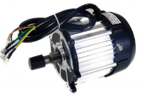

A Brushless DC motor (BLDC) is a type of electric motor that uses an electronic commutation system instead of brushes to regulate the motor's operation. BLDC motors are more efficient, reliable, and quieter than traditional brushed motors, making them a popular choice in a wide range of applications.

BLDC motors operate by using a permanent magnet rotor and a stator with windings that are energized in a specific sequence to produce rotational movement. The energization of the windings is controlled by an electronic commutation system, which uses sensors to detect the position of the rotor and adjust the current flow accordingly.

The absence of brushes in a BLDC motor eliminates the friction and wear associated with traditional brushed motors, resulting in longer lifetimes and less maintenance. The electronic commutation system also provides precise control over the motor's speed and torque, allowing for better efficiency and performance.

BLDC motors are used in a wide range of applications, including electric vehicles, drones, industrial automation, and robotics. They are particularly well-suited for applications where high efficiency, precise control, and low noise are required.

Overall, BLDC motors offer a range of benefits over traditional brushed motors, including higher efficiency, greater reliability, and improved performance. Their versatility and flexibility make them a popular choice for a wide range of applications in many different industries.

1. 1800W 40A DC to DC Adjustable Constant Voltage and Current Power Supply Module

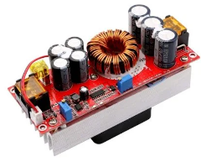

The 1800W 40A DC to DC Adjustable Constant Voltage and Current Power Supply Module is an electronic device that converts DC power from one voltage level to another, while regulating both the voltage and current output to provide a constant level of power to a load.

This power supply module is designed to handle up to 1800 watts of power and 40 amps of current, making it suitable for a wide range of applications, including industrial equipment, LED lighting, and power tools.

The module includes adjustable voltage and current output settings, which can be set using potentiometers or digital controls, depending on the model. This allows for precise control over the power supplied to the load, ensuring that it receives the required amount of power without being damaged by overvoltage or overcurrent conditions.

The module also includes overvoltage and overcurrent protection, which can prevent damage to the load in the event of an unexpected surge in voltage or current. Additionally, the module may include other features, such as short-circuit protection and thermal protection, to further safeguard against potential damage or failure.

Overall, the 1800W 40A DC to DC Adjustable Constant Voltage and Current Power Supply Module is a versatile and reliable device that provides precise control over power output for a wide range of applications. Its adjustable settings and built-in protections make it a popular choice for industrial and commercial use, where reliability and safety are critical.

1. Arduino Uno

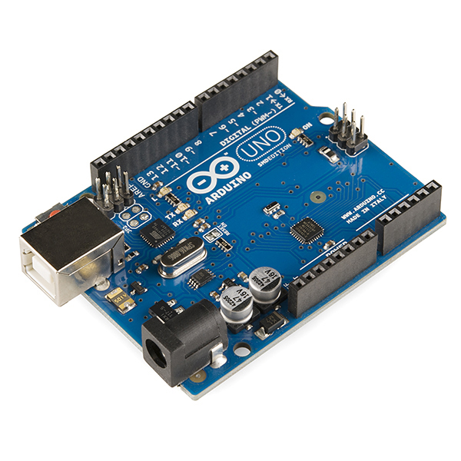

The Arduino UNO is a microcontroller board that is designed to be easy to use for hobbyists, students, and professionals who want to create electronic projects. It is one of the most popular and widely used microcontroller boards in the world.

The board is based on the ATmega328P microcontroller, which is a low-power, high-performance chip that can be programmed to perform a variety of functions. It includes 14 digital input/output pins, 6 analog inputs, and a variety of other features that make it ideal for a wide range of applications.

One of the key features of the Arduino UNO is its simplicity and ease of use. The board can be easily connected to a computer via a USB cable, and programming can be done using the Arduino integrated development environment (IDE), which is a free, open-source software tool that is available for Windows, Mac, and Linux.

The Arduino UNO can be used to control a wide range of electronic devices and systems, including sensors, motors, lights, and displays. It can be programmed using C/C++ programming languages, and a wide range of libraries and examples are available to help users get started with their projects.

Overall, the Arduino UNO is a powerful and versatile microcontroller board that is ideal for anyone who wants to create electronic projects, from beginners to experienced professionals. Its ease of use and extensive community support make it a popular choice for makers, students, and hobbyists around the world.

1. Raspberry Pi 4

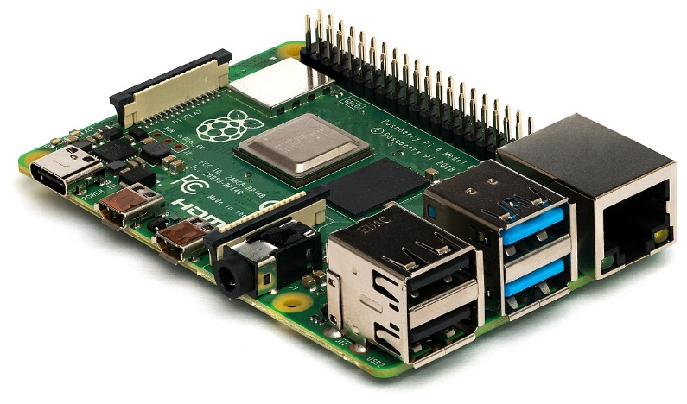

The Raspberry Pi 4 is a credit card-sized single-board computer that is designed for hobbyists, students, and professionals who want to create a variety of electronic projects. It is the latest model in the Raspberry Pi series, and it includes a number of improvements over previous models.

The Raspberry Pi 4 is powered by a quad-core ARM Cortex-A72 CPU, which is clocked at 1.5 GHz. It is available in three different RAM configurations: 1 GB, 2 GB, or 4 GB. The board includes a variety of input/output options, including two micro-HDMI ports that support 4K displays, two USB 3.0 ports, two USB 2.0 ports, and a gigabit Ethernet port. It also includes a microSD card slot for storing the operating system and data.

One of the key features of the Raspberry Pi 4 is its versatility. It can be used for a wide range of applications, including home automation, media centers, game consoles, and robotics. It can run a variety of operating systems, including the popular Raspbian OS, as well as Ubuntu, Debian, and others.

The Raspberry Pi 4 is also very user-friendly. It can be easily set up and configured using the Raspberry Pi Imager software, which is available for Windows, Mac, and Linux. It includes a wide range of programming languages and development tools, making it easy for users to create their own applications and projects.

Overall, the Raspberry Pi 4 is a powerful and versatile single-board computer that is ideal for a wide range of electronic projects. Its small size, low cost, and user-friendly features make it a popular choice for hobbyists, students, and professionals alike.

1. Universal Battery Elimination Circuit

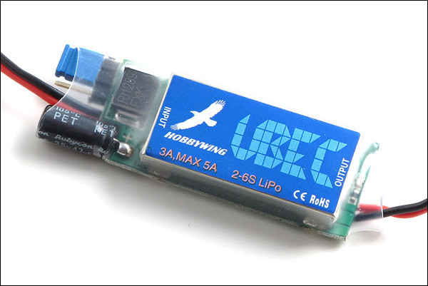

It is an electronic device that is used to regulate the voltage from a battery or power source to a lower, constant voltage that is suitable for powering electronic devices.

UBECs are commonly used in radio-controlled (RC) hobby applications, such as RC airplanes and cars, to provide a stable and reliable power source to electronic components such as servos, receivers, and flight controllers. They are also used in robotics, unmanned aerial vehicles (UAVs), and other electronic projects.

UBECs typically include a switching regulator that converts the input voltage to a lower, regulated voltage output. They also include input and output connectors, as well as protection features such as over-current and over-temperature protection.

One of the key advantages of UBECs is their ability to provide a constant voltage output regardless of changes in the input voltage, such as fluctuations in the battery voltage or changes in load. This helps to ensure that electronic components receive a stable and reliable power source, which is essential for proper operation and longevity.

Overall, UBECs are essential electronic devices for anyone working with electronic components that require a stable and reliable power source. They are easy to install, operate, and provide a cost-effective solution for powering electronic devices.

1. TF Mini-S Micro LiDAR Distance Sensor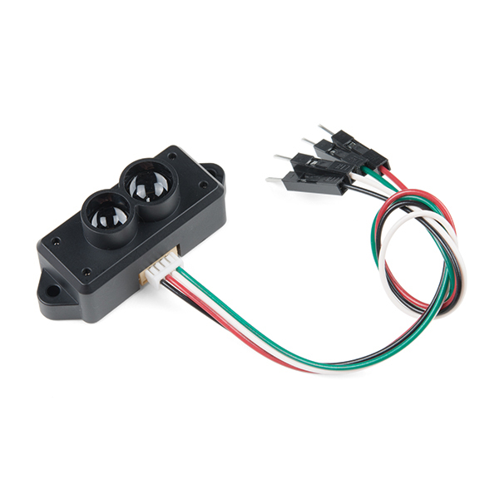

The TF Mini-S Micro LiDAR Distance Sensor is a small, lightweight sensor that is designed to measure distances between objects using laser light. It is commonly used in robotics, drones, and other electronic projects where accurate distance measurements are required.

The TF Mini-S sensor uses infrared light to measure distances, and can accurately detect objects up to 12 meters away with a resolution of 1 centimeter. It has a small form factor and low power consumption, making it ideal for use in small and portable electronic projects.

The sensor is easy to use and can be connected to a microcontroller board or other electronic device using UART communication protocol. It also includes various configuration options, such as adjusting the detection range and frequency.

One of the key advantages of the TF Mini-S sensor is its reliability and accuracy. It uses advanced signal processing algorithms to filter out noise and interference, and can provide accurate distance measurements even in challenging environments.

Overall, the TF Mini-S Micro LiDAR Distance Sensor is a versatile and reliable sensor that is ideal for a wide range of electronic projects. Its small size, low power consumption, and high accuracy make it a popular choice for hobbyists, students, and professionals alike.

1. Tinker Edge R

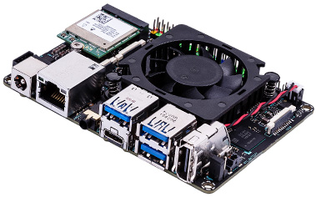

The Tinker Edge R is a single-board computer (SBC) developed by ASUS that is designed for edge computing and artificial intelligence (AI) applications. It is powered by the Rockchip RK3399Pro processor, which includes a built-in neural processing unit (NPU) for accelerating AI inference tasks.

The Tinker Edge R includes 4GB of LPDDR4 RAM and 16GB of eMMC storage, as well as a microSD card slot for additional storage. It includes a variety of input/output options, including four USB 3.2 Gen1 Type-A ports, a gigabit Ethernet port, a 3.5mm audio jack, and a micro-HDMI port that supports 4K displays.

One of the key features of the Tinker Edge R is its AI acceleration capabilities. The built-in NPU can perform up to 3.0 TOPS (trillion operations per second) of neural network inference performance, making it suitable for a wide range of AI applications such as image recognition, natural language processing, and robotics.

The Tinker Edge R also includes support for various AI development frameworks, including TensorFlow, Caffe, and PyTorch. It runs on Debian 10 operating system, and includes various software tools for developing and deploying AI applications.

Overall, the Tinker Edge R is a powerful and versatile SBC that is ideal for AI and edge computing applications. Its high-performance NPU and AI development tools make it a popular choice for developers, researchers, and hobbyists who want to explore the latest AI technologies.

1. Stepper Motor NEMA 23

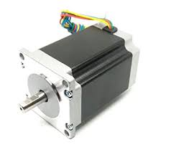

The NEMA 23 stepper motor is a type of high-performance motor that is commonly used in a wide range of industrial, automation, and robotics applications. It is named after the National Electrical Manufacturers Association (NEMA), which sets standards for the design and performance of electrical equipment.

The NEMA 23 stepper motor is a four-phase motor that operates by rotating its shaft in small, precise steps. It has a shaft diameter of 6.35 mm and a faceplate size of 57.2 x 57.2 mm. It is capable of producing high torque at low speeds, making it ideal for applications that require precise control over motion and positioning.

The motor typically has a step angle of 1.8 degrees per step, which means that it rotates 200 steps per revolution. It can operate at various voltages and current levels, depending on the specific application requirements.

One of the key advantages of the NEMA 23 stepper motor is its high accuracy and repeatability. It is able to maintain its position even when power is not applied, which makes it ideal for applications that require holding or locking torque.

Overall, the NEMA 23 stepper motor is a powerful and versatile motor that is widely used in various industrial and automation applications. Its precise control and high accuracy make it a popular choice for applications such as CNC machines, 3D printers, robotics, and other motion control systems.

## Software Requirements

1. Operating System - Windows 11, 10, 8, 7, Ubuntu

2. Documentation -MS Word, MS PowerPoint, MS Excel.

3. Language – Python, Embedded C, Linux

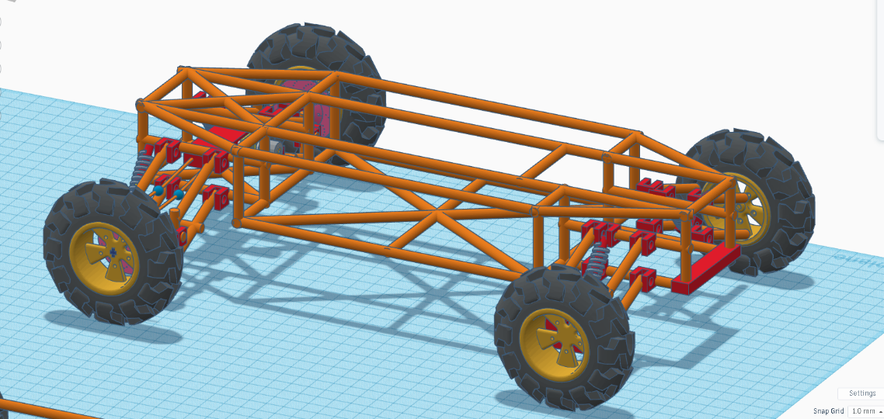

*Fig 5.10 Skeleton*

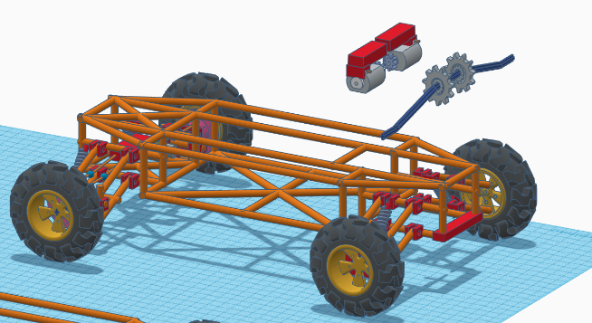 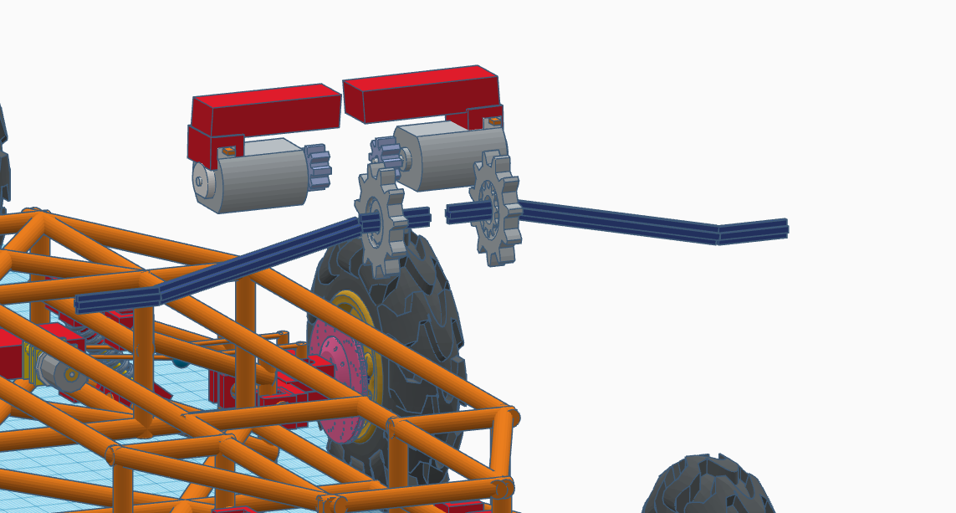

*Fig 5.11 Drive Train*

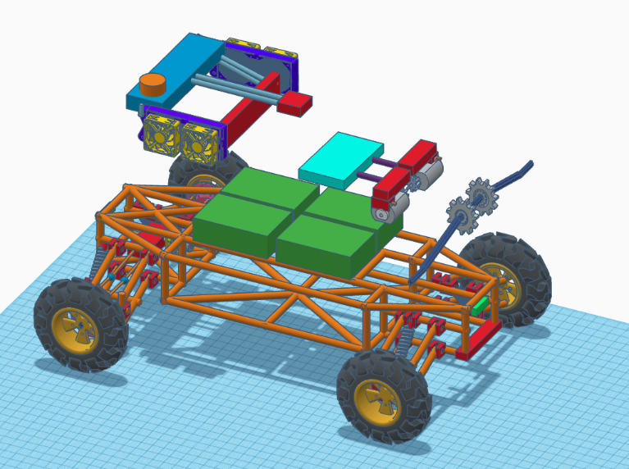

*Fig 5.12 Complete components*

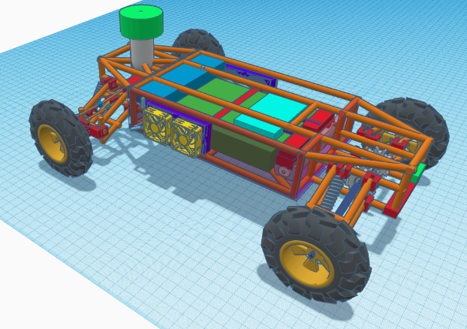

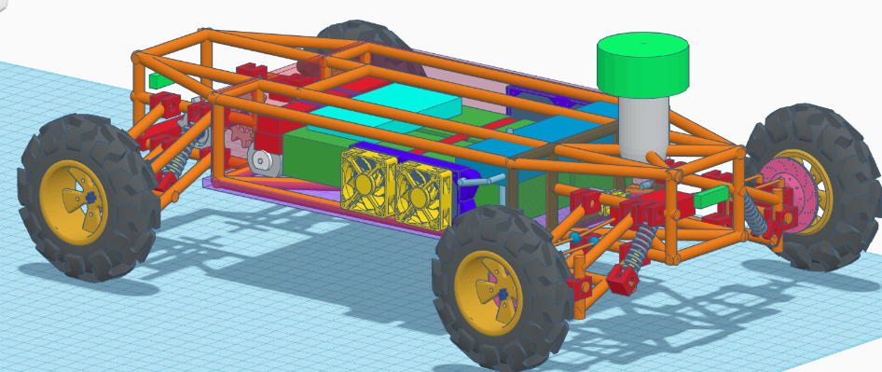

*5.13 finished product*

# Conclusion

In conclusion, our UAV components have been decided and we have also decided upon the software to be used has also been confirmed, we now have to assemble the parts and embed it to the microcontrollers for it to communicate with each other.

The project was initiated considering the first-mile involved in the delivery of the product from one place to another. This product also has various other applications like using it in factories in large scale for product recognition and transportation. This can also be developed for military use for various purposes.

This technology can be used and scaled at levels which can reform how UAV's approach problems and collaborate with other researchers from distant places without worrying about breaching data privacy laws. Due to the high security features provided by ROS the vehicle can also advance and used in various fields.

# REFERENCES

[1] Atia, M.M., Hilal, A.R., Stellings, C., Hartwell, E., Toonstra, J., Miners, W.B. and Basir, O.A. (2017), “A low-cost lane-determination system using GNSS/IMU fusion and HMM-Based multistage map matching”, IEEE Transactions on Intelligent Transportation Systems, Vol. 18 No. 11, pp. 1-11.

[2]  Baruch, J. (2016), “*Steer driverless cars towards full automation*”, Nature, Vol. 536, p. 127.

[3] Gim Hee Lee, F.F. and Pollefeys, M. (2013), “*Motion estimation for self-driving cars with a generalized camera*”, IEEE Conference on Computer Vision and Pattern Recognition, Portland, OR, pp. 2746-2753.

[4] Lee, J.-G., Kim, K.J., Lee, S. and Shin, D.-H. (2015), “*Can autonomous vehicles be safe and trustworthy? Effects of appearance and autonomy of unmanned driving systems*”, International Journal of Human-Computer Interaction, Vol. 31 No. 10, pp. 682-691.

[5] Mohamed, R., Aly, H. and Youssef, M. (2017), “*Accurate real-time map matching for challenging environments*”, Transactions on Intelligent Transportation Systems, Vol. 18 No. 4, pp. 847-857.

[6]  N. Kassem, A. E. Kosba, and M. Youssef, “RF-based vehicle detection and speed estimation,” in Proc. IEEE VTC—Spring, 2012, pp. 1–5.

[7] X. Zhao, P. Sun, Z. Xu, H. Min, H.Y. Asvadi, L. Garrote, C. Premebida, P. Peixoto, U.J. Nunes, Multimodal vehicle detection: fusing 3D-LIDAR and color camera data. Pattern Recogn. Lett. (2017)